Instructor Manual

Chapter 1: The Role and Method of Economics

Learning Outcomes
After reading this chapter, the student should be able to:
1.1 Define and describe what is meant by the term economics
1.2 Describe what economists mean when the say that people engage in rational behavior and respond to incentives in predictable ways
1.3 Define and explain economic theories and models
1.4 Describe the difference between correlation and causation
1.5 Define and explain the distinction between positive statements and normative statements

Chapter Outcome
After completing this chapter and the associated materials, the student will be able to evaluate the central constructs, theories, models, and methodologies of economics.

Context and Purpose
Many issues in our lives are at least partly economic in character. Economics is a unique way of analyzing many areas of human behavior. Indeed, the range of topics to which economic analysis can be applied is broad. Many researchers discover that the economic approach to human behavior sheds light on social problems that have been with us for a long time: discrimination, crime, divorce, political favoritism, and more.
However, before we delve into the details and models of economics, it is important that we present an overview of how economists approach problems—their methodology. How does an economist apply the logic of science to approach a problem? And what are the pitfalls that economists should avoid in economic thinking? We will also discuss why economists disagree.

Key Points
- Economics is the study of choices we make among our many wants and desires given our limited resources (inputs used to produce goods and services).
- Scarcity refers to the situation that exists because our unlimited wants exceed our limited resources.
- By self-interest, economists simply mean that people try to improve their own situation (as they see it, not necessarily as others see it). Self-interest can also include benevolence.
- When economists use the term self-interest, they are not implying that people are invariably selfish. Many acts of selfless behavior may be self-interested. For example, people may be kind to others in hopes that the same behavior will be returned.
- To an economist, rational behavior merely means that people do the best they can, based on their values and the available information, under current and anticipated future circumstances.
- Theories and models are explanations of how things work that help us understand and predict how and why economic agents such as consumers, producers, firms, government, and so on behave the way they do. That is, we use theories and models to observe how people really behave.
- A good economic theory or model weeds out the irrelevant facts from the relevant ones. We must abstract. Without abstraction or simplification, the world is too complex to analyze.
- In economic theory, a hypothesis is a testable prediction about how people will behave or react to a change in economic circumstances. Empirical analysis is the use of data to test a hypothesis.
- Virtually all economic theories share a condition usually expressed by the Latin phrase ceteris paribus. A rough translation of this phrase is “letting everything else be equal” or “holding everything else constant.” When economists try to assess the effect of one variable on another, they must keep the relationship between the two variables isolated from other events that might also influence the situation that the theory tries to explain or predict.
- Microeconomics deals with the smaller units within the economy, attempting to understand the decision-making behavior of firms and households and their interaction in markets for particular goods or services. Macroeconomics, in contrast, deals with the aggregate, or total, economy; it looks at economic problems as they influence the whole of society.
- One must always be careful not to confuse correlation with causation. In other words, the fact that two events usually occur together (correlation) does not necessarily mean that one caused the other to occur (causation).
- To avoid the fallacy of composition one must recognize that even if something is true for an individual, it is not necessarily true for many individuals as a group.
- A positive statement is an objective, testable statement that describes what happens and why it happens. A normative statement is a subjective, contestable statement that attempts to describe what should be done. The majority of disagreements in economics stem from normative issues; differences in values or policy beliefs result in conflict.

Chapter Outline

1.1 Economics: A Brief Introduction
1.1a Economics—a word with many different meanings
- Precisely defined, economics is the study of the choices we make among our many wants and desires given our limited resources.
- Resources are inputs—land, human effort, skills, and machines and factories, for instance—used to produce goods and services.
- The problem is that our unlimited wants exceed our limited resources, a fact that we call scarcity.
- Scarcity exists because human wants for goods and services exceed the number of goods and services that can be produced using all of our available resources.
- This is the economic problem: Scarcity forces us to choose, and choices are costly because we must give up other opportunities that we value.
FAQ
This is a great opportunity to encourage students to think like economists. Ask them to consider decisions they have made in which nonfinancial costs came into play. When has time been a “cost”? What other types of costs might they incur?
1.1b Economics is all around us
- The economic problem is evident in every aspect of our lives.
- The tools of economics are far reaching, even beyond the choices we make in our everyday lives.
FAQ
Ask students to characterize the relationship between scarcity and trade-offs. How do they make decisions about tradeoffs?

Section Quiz
1. If a good is scarce, ______.
a. it only needs to be limited
b. it is not possible to produce any more of the good
c. our unlimited wants exceed our limited resources
d. our limited wants exceed our unlimited resources
Ans: C

2. Which of the following is true of resources?
a. Their availability is unlimited.
b. They are the inputs used to produce goods and services.
c. Increasing the number of resources available could eliminate scarcity.
d. Both they are the inputs used to produce goods and services and increasing the number of resources available could eliminate scarcity.
Ans: B

3. If scarcity were not a fact, ______.
a. people could have all the goods and services they wanted for free
b. it would no longer be necessary to make choices
c. poverty, defined as the lack of a minimum level of consumption, would also be eliminated
d. all of these would be true
Ans: D

4. Economics is concerned with ______.
a. the choices people must make because resources are scarce
b. human decision makers and the factors that influence their choices
c. the allocation of limited resources to satisfy unlimited wants
d. all of these
Ans: D

5. What is the definition of economics?
Ans: Economics is the study of the choices we make among our many wants and desires given our limited resources.

6. Why does scarcity force us to make choices?
Ans: Scarcity—the fact that our wants exceed what our resources can produce—means that we are forced to make choices about how best to use these limited resources.

7. Why are choices costly?
Ans: In a world of scarcity, whenever we choose one option, we also choose to do without something else that we also desire. The want that we choose not to satisfy is the opportunity cost of that choice.

8. What is the economic problem?
Ans: Scarcity forces us to choose, and choices are costly because we must give up other opportunities that we value. This is the economic problem. Every individual, every business, and every social, religious, and governmental organization faces the economic problem. Every society, whether it is capitalistic, socialistic, or totalitarian, must also face the economic problem of scarcity, choices, and costs.

9. Why do even “non-economic” issues have an economic dimension?
Ans: Even apparently non-economic issues have an economic dimension, because economics concerns anything worthwhile to some human being (including love, friendship, charity, etc.) and the choices we make among the things we value.

1.2 Economic Behavior
1.2a Self-interest
- Economists assume that most individuals act as if they are motivated by self-interest and respond in predictable ways to changing circumstances.
- In other words, self-interest is a good predictor of human behavior in most situations.
Tips
A useful illustration of self-interest is to ask what kind of nails a steel maker would likely make if it was rewarded on the basis of the weight of nails produced (railroad spikes, as it is less costly to produce a given weight of nails that way) and contrast it to what it would likely make if it was rewarded on the basis of the number of nails made (pins, as it is less costly to produce a given number of pins than larger nails). Those results can then be compared to what would happen if the steel maker was rewarded by being allowed to keep any profits (it would make those products it thought people valued at more than the cost of producing them, which depends on what people value in their current circumstances).
Students sometimes struggle with economics’ self-interest assumption because they often consider themselves to be acting altruistically. Point out to students that the belief that they are more altruistic than they really are is consistent with self-interest (we want to think well of ourselves), and then ask them whether they think self-interest or altruism is a more reliable way to get others to coordinate behavior with them in a society (as in Adam Smith’s famous quote). This can result in an interesting classroom discussion.
- Critics will say people don’t think that way, and the critics might be right.
  - But economists are arguing that people act that way. Economists are observing and studying what people do—their actions.
  - Furthermore, when economists use the term self-interest, they are not implying that people only seek to maximize their material consumption.
  - Many acts of selfless behavior may be self-interested. For example, people may be kind to others in hopes that the same behavior will be returned.
FAQ
Ask students whether they believe others pursue their own self-interest. Ask them for examples of when people seem to act in ways that are not consistent with their own self-interest and explore how reconceptualizing the choices might indicate that they are acting in their own self-interest.
1.2b What is rational behavior?
- Economists assume that people, for the most part, engage in rational, or purposeful, behavior.
  - To an economist, rational behavior merely means that people do the best they can, based on their values and the available information, under current and anticipated future circumstances.
Tips
The connection between economics and other social sciences can be illustrated by behavior modification in psychology. Behavior modification can be shown to be an application of the rule of rational choice, where you raise the marginal benefit or lower the marginal cost of behavior you want to encourage (like a subsidy) and lower the marginal benefit or raise the marginal cost of behavior you want to discourage (like a tax).

FAQ
How does the definition of rational behavior used by economists differ from everyday uses of the term rational (i.e., based on reason or logic)? Can seemingly irrational factors play come into play in the conceptualization of rational behavior used by economists?
- Economists assume that people do not intentionally make decisions that will make them worse off.
  - Most people act purposefully.
  - They make decisions with some expected outcome in mind.
Great Economic Thinkers
Review Adam Smith’s contributions to economic thought and ask them to consider whether those insights are still true today:
Smith believed that the wealth of a nation did not come from the accumulation of gold and silver—the prevailing thought of the day. Smith observed that people tend to pursue their own personal interests and that an “invisible hand” (the market) guides their self-interest, increasing social welfare and general economic well-being. Smith’s most powerful and enduring contribution was this idea of an invisible hand of market incentives channeling individuals’ efforts and promoting social welfare.
Smith also showed that through the division of labor and the specialization of tasks, producers could increase their output markedly. While Smith did not invent the market, he demonstrated that free markets, unfettered by monopoly and government regulation, and free trade were at the very foundation of the wealth of a nation.

Section Quiz
1. Which of the following would reflect self-interested behavior to an economist?
a. worker pursuing a higher-paying job and better working conditions
b. consumer seeking a higher level of satisfaction with her current income
c. Mother Teresa using her Nobel Prize money to care for the poor
d. all of these
Ans: D

2. When economists assume that people act rationally, it means they ______.
a. always make decisions based on complete and accurate information
b. make decisions that will not be regretted later
c. do the best they can based on their values and information under current and future circumstances
d. make decisions based solely on what is best for society
e. commit no errors in judgment
Ans: C

3. Rational self-interest can include the welfare of ______.
a. our family
b. our friends
c. the poor people of the world
d. all of these
Ans: D

4. Rational self-interest means that ______.
a. people never make mistakes
b. our concerns for others do not involve costs
c. we are materialistic and selfish
d. people make decisions with some desired outcome in mind
Ans: D

5. What do economists mean by self-interest?
Ans: By self-interest, economists simply mean that people try to improve their own situation (as they see it, not necessarily as others see it). Self-interest can also include benevolence.

6. What does rational self-interest involve?
Ans: Economists consider individuals to be acting in their rational self-interest if they are striving to do their best to achieve their goals with their limited income, time, and knowledge, and given their expectations of the likely future consequences of their behavior (both benefits and costs).

7. How are self-interest and selfishness different?
Ans: Self-interest means that people are striving to do their best to achieve their goals, which may or may not be selfish. Parents working more hours to give more to their children or a favorite charity can be self-interested but are not selfish.

8. What is rational behavior?
Ans: Rational behavior is when people do the best they can based on their values and information, under current and anticipated future consequences. Rational individuals weigh the benefits and costs of their actions, and they pursue actions only if they perceive their benefits to be greater than their costs.

1.3 Economic Theories and Models
1.3a Economic theories and models
- Theories and models are explanations of how things work that help us understand and predict how and why economic agents such as consumers, producers, firms, government, and so on behave the way they do. We use theories and models to observe how people really behave.
Tips
As an example of the approach used in economic theorizing and modeling, ask students whether an airplane model needs to have wings and seats. Typically, some will say both and others will say only wings are necessary. Then ask what difference it makes whether the model is intended to train stewardesses for their jobs or to investigate a plane’s aerodynamics. They will quickly see that the right sort of model will reflect its intended use; abstracting from those aspects that are unimportant to the question at hand to better focus on the important considerations you want to investigate.
1.3b Abstraction is important
- A good economic theory or model weeds out the irrelevant facts from the relevant ones.
- We must abstract. Without abstraction or simplification, the world is too complex to analyze.
  - Economic theories and models are like a road map in that they are more useful when they ignore details that are not relevant to the questions that are being investigated.
1.3c Developing a testable proposition
- The beginning of any theory is a hypothesis, a testable proposition that makes some type of prediction about behavior in response to certain changes in conditions based on our assumptions. In economic theory, a hypothesis is a testable prediction about how people will behave or react to a change in economic circumstances.
- Using empirical analysis
  - To determine whether our hypothesis is valid, we must engage in empirical analysis. That is, we must examine the data to see whether our hypothesis fits well with the facts.
- From hypothesis to theory
  - If it is supported, the hypothesis can be tentatively accepted as an economic theory.
- Every economic theory is on lifelong probation; the hypothesis underlying an economic theory is constantly being tested against empirical findings.
Tips
A useful illustration of how models come to be accepted in science is the replacement of the Ptolemaic geocentric model of the solar system (everything revolves around the earth at the center) with the Copernican heliocentric model of the solar system (everything revolves around the sun). With the development of improving telescopes, more of the solar system could be seen. But as a result, it eventually became impossible to construct a geocentric model that was consistent with empirical observations, while those observations were consistent with a heliocentric model, leading to the replacement of one previously accepted model with another.
1.3d The ceteris paribus assumption
- Virtually all economic theories share a condition usually expressed by the Latin phrase ceteris paribus.
  - A rough translation of the phrase is “letting everything else be equal” or “holding everything else constant.”
  - When economists try to assess the effect of one variable on another, they must keep the relationship between the two variables isolated from other events that might also influence the situation that the theory tries to explain or predict.
1.3e Why are observation and prediction harder in the social sciences?
- Working from observations, scientists try to make generalizations that will enable them to predict certain events.
  - However, observation and prediction are more difficult in the social sciences than in physical sciences such as physics, chemistry, and astronomy because social scientists are concerned with human behavior.
1.3f Why do economists predict on a group level?
- Economists’ predictions usually refer to the collective behavior of large groups rather than that of specific individuals because looking at the behaviors of a large group allows economists to discern general patterns of actions.
- What does individual behavior tell us?
  - Individual behavior can be difficult to predict.
- What does group behavior tell us?
  - Group behavior is often more predictable than individual behavior.
FAQ
Ask students to consider why group behavior is easier to predict than individual behavior.
- Economists and survey data
- Economists do not typically use survey data. Economists prefer to look at revealed preferences (how people actually behave) rather than declared preferences (how they say they behave).
Tips
The text emphasizes economics as a disciplined way of thinking, not the source of clear-cut answers for every circumstance. It is worth emphasizing why the economic way of thinking points towards “it depends” as the first part of the answer to general economic questions (because the expected marginal benefits and expected marginal costs of choices depend on so many factors).
It is worth emphasizing that economic principles allow economists to know better what not to do than what to do. We can identify choices that would do poorly in achieving intended goals under virtually any set of circumstances, but we don’t know what course of action will be the best possible in a complex world of uncertainty and change. I note to my students that this is a big difference between exam questions that have to give students enough information to produce a best answer and the real world, where the necessary information is often unknown.
1.3g The two branches of economics: microeconomics and macroeconomics
- Microeconomics deals with the smaller units within the economy, attempting to understand the decision-making behavior of firms and households and their interaction in markets for particular goods or services.
  - Microeconomics topics include discussions of health care, agricultural subsidies, the price of everyday items such as running shoes, the distribution of income, and the impact of labor unions on wages.
- Macroeconomics, in contrast, deals with the aggregate, or total, economy; it looks at economic problems as they influence the whole of society.
  - Topics covered in macroeconomics include discussions of inflation, unemployment, business cycles, and economic growth.

Section Quiz
1. Economists use theories and models to ______.
a. abstract from the complexities of the world
b. understand economic behavior
c. explain and help predict human behavior
d. do all of these
e. do none of these
Ans: D

2. The importance of the ceteris paribus assumption is that it allows one to ______.
a. separate subjective issues from objective ones
b. generalize from the whole to the individual
c. analyze the relationship between two variables apart from the influence of other variables
d. hold all variables constant so that the economy can be carefully observed in a suspended state
Ans: C

3. When we look at a particular segment of the economy, such as a given industry, we are studying ______.
a. macroeconomics
b. microeconomics
c. normative economics
d. positive economics
Ans: B

4. Which of the following is most likely a topic of discussion in macroeconomics?
a. an increase in the price of a pizza
b. a decrease in the production of stereos by a consumer electronics company
c. an increase in the wage rate paid to automobile workers
d. a decrease in the unemployment rate
e. the entry of new firms into the software industry
Ans: D

5. What are economic theories and models?
Ans: A theory, or model, is an established explanation that accounts for known facts or phenomena. Economic theories and models are statements or propositions about patterns of human behavior that are expected to take place under certain circumstances.

6. What is the purpose of a theory or a model?
Ans: The purpose of a theory is primarily to explain and predict well. Theories are necessary because the facts of a complex world do not organize themselves.

7. Why must economic theories and models be abstract?
Ans: Economic theories and models must be abstract because they could not possibly include every possible event, circumstance, or factor that might affect behavior. Like a road map, economic theories and models abstract from some issues to focus more clearly and precisely on the central questions they are designed to understand.

8. What is a hypothesis? How do we determine whether it is tentatively accepted?
Ans: A hypothesis is a testable proposal that makes some type of prediction about behavior in response to certain changed conditions. An economic hypothesis is a testable proposal about how people will behave or react to a change in economic circumstances. It is tentatively accepted if its predictions are consistent with what actually happens. In economics, testing involves empirical analysis to see whether the hypothesis is supported by the facts.

9. Why do economists hold other things constant (ceteris paribus)?
Ans: The hold-other-things-constant, or ceteris paribus, assumption is used in economics because in trying to assess the effect of one variable on another, we must isolate the variables’ relationship from other important events or variables that might also influence the situation the theory tries to explain or predict.

10. Why are observation and prediction more difficult in the social sciences?
Ans: Observation and prediction are more difficult in the social sciences than in the physical sciences because social sciences are concerned with human behavior, which is more variable and often less readily predictable than the behavior of experiments observed in a laboratory. Social scientists can seldom run truly “controlled” experiments like those of biological scientists.

11. Why do economic predictions refer to the behavior of groups of people rather than individuals?
Ans: Economists’ predictions usually refer to the collective behavior of large groups rather than individuals because looking at the behaviors of a large group of individuals allows economists to discern general patterns of actions and therefore make more reliable generalizations.

12. Why do economists prefer revealed preference over declared preference?
Ans: Researchers find that their results are more accurate when they observe what people do (revealed preferences) rather that what they say they do (declared preferences).

13. Why is the market for running shoes considered a microeconomic topic?
Ans: Because a single industry is “small” relative to the economy as a whole, the market for running shoes (or the running-shoe industry) is a microeconomic topic.

14. Why is inflation considered a macroeconomic topic?
Ans: Inflation—a change in the overall price level—has effects throughout the entire economy, rather than just in certain small areas of the economy, which makes it a macroeconomic topic.

1.4 Pitfalls to Avoid in Scientific Thinking
1.4a Confusing correlation and causation
- The fact that two events usually occur together (correlation) does not necessarily mean that one caused the other to occur (causation).
- Why is the correlation between ice cream sales and property crime positive?
  - Did you know that when ice cream sales rise, so do property crime rates? What do you think causes the two events to occur together?
  - The explanation is that property crime peaks in the summer because of warmer weather, more people on vacations (leaving their homes vacant), teenagers out of school, and so on. It just happens that ice cream sales also peak in those months because of the weather. It is a case of a third variable causing both to occur.
1.4b The fallacy of composition
- Economic thinking requires us to be aware of the problems associated with aggregation (adding up all the parts).
- One of the biggest problems is the fallacy of composition.
  - To avoid this fallacy one must recognize that even if something is true for an individual, it is not necessarily true for many individuals as a group.
Tips
I find rain dancing to be a good illustration of confusing correlation with causation. If a group of people decides that a deity that brings them rain needs its anger appeased by rain dancing at the beginning of the normal rainy season and they dance long enough, it will rain. It will not rain because they danced, but because the rainy season started. But once a belief in the necessity of rain dancing has begun, it can be very hard to change, since every time they dance (if they dance long enough), it rains.
Weather can be used to illustrate problems of establishing causation. Since heaters come on in the winter and air conditioners in the summer, one could conclude that heaters cause the house to be colder and air conditioners cause it to be hotter. Similarly, chill drafts can be blamed for catching a cold in the winter (since looking back, it is easy to remember being exposed to some recent draft in the winter), even though the more scientific reason is that you are inside more, closely exposed to more of other people’s “bugs,” in the winter than in the summer.
In addition to the fallacy of composition illustrations in the text, you could add leaving early to beat the traffic (or arriving early to beat the crowd) and cutting your price to take sales from rivals (which doesn’t work if all rivals lower their prices).

Section Quiz
1. Which of the following statements can explain why correlation between Event A and Event B may not imply causality from A to B?
a. The observed correlation may be coincidental.
b. A third variable may be responsible for causing both events.
c. Causality may run from Event B to Event A instead of in the opposite direction.
d. All of these can explain why the correlation may not imply causality.
Ans: D

2. Ten-year-old Tommy observes that people who play football are larger than average and tells his mom that he’s going to play football because it will make him big and strong. Tommy is ______.
a. committing the fallacy of composition
b. violating the ceteris paribus assumption
c. mistaking correlation for causation
d. committing the fallacy of decomposition
Ans: C

3. The fallacy of composition is ______.
a. a problem associated with aggregation
b. the incorrect view that what is true for the individual is always true for the group
c. illustrated in the following statement: If I stand up at a football game, I will be able to see better; therefore, if we all stood up, we would all see better
d. all of these
Ans: D

4. What is the relationship between correlation and causation?
Ans: Correlation means that two things are related; causation means that one thing caused the other to occur. Even though causation implies correlation, correlation does not necessarily imply causation.

5. What types of misinterpretation result from confusing correlation and causation?
Ans: Confusing correlation between variables with causation can lead to misinterpretation where a person “sees” causation between two variables or events where none exists or where a third variable or event is responsible for causing both of them.

6. What is the fallacy of composition?
Ans: The fallacy of composition is the incorrect idea that if something is true for an individual, it must also be true for many individuals as a group.

7. If you can sometimes get a high grade on an exam without studying, does it mean that additional studying does not lead to higher grades? Explain your answer.
Ans: In some instances, a student can get a high grade on an exam without studying. However, because additional studying increases mastery of the material, additional studying would typically increase test performance and grades. That is, even though added studying would not raise grades in some unusual situations, as a generalization, additional studying does lead to higher grades.

1.5 Positive Statements and Normative Statements
1.5a Positive statement
- Most economists view themselves as scientists seeking the truth about the way people behave. This objective, value-free approach, based on the scientific method, is called positive analysis. In positive analysis, we want to know the impact of variable A on variable B.
  - A positive statement is an objective, testable statement that describes what happens and why it happens
FAQ
To help students understand the essential features of the scientific method, as them to consider whether positive statements must be true or just testable.
1.5b Normative statement
- Economists, like anyone else, have opinions and make value judgments.
- Normative statements involve judgments about what should be or what ought to happen.
  - For example, normative questions might include the following: Should the government raise the minimum wage? Should the government increase spending on the space program? Should the government give “free” prescription drugs to senior citizens?
1.5c Positive versus normative analysis
- The distinction between positive and normative analysis is important.
  - It is one thing to say that everyone should have universal health care, an untestable normative statement, and quite another to say that universal health care would lead to greater worker productivity, a testable positive statement.
- It is important to distinguish between positive and normative analysis because many controversies in economics revolve around policy considerations that contain both.
  - When economists are trying to explain the way the world works, they are scientists.
  - When economists start talking about how the economy should work rather than how it does work, they have entered the normative world of the policy maker.
FAQ
To reinforce the distinction between positive and normative analysis, ask students to consider whether positive analysis can prove that a particular policy is good.
1.5d Disagreement is common in most disciplines
- Although economists do frequently have opposing views on economic policy questions, they probably disagree less than the media would have you believe.
- Disagreement is common in most disciplines.
  - The majority of disagreements in economics stem from normative issues; differences in values or policy beliefs result in conflict.
  - Economists may also disagree about the validity of a given economic theory for the policy in question—that is, they disagree about the positive analysis.
Tips
Emphasize that disagreements about economic policy can occur even when people agree on the list of benefits and costs of an action or policy (positive statements), as long as they disagree about the relative weights or values to place on those outcomes (normative statements). This is often the case when people perceive conflicts between freedom and fairness (the text example). President Harry Truman’s famous complaint that he couldn’t find a one-armed economist (who would tell him which policy was the right one), but only the two-armed kind, whose policy answers were always on the one hand (the benefits)...and on the other hand (the costs)..., forcing him to decide whether the list of benefits was more valuable than the list of costs, is also an excellent illustration.
1.5e Often economists do agree
- According to a survey of members of the American Economic Association, most economists agree on a wide range of issues, including the effects of rent control, import tariffs, export restrictions, the use of wage and price controls to curb inflation, and the minimum wage.
FAQ
Ask students whether economists tend to agree or disagree on important issues. You may want to use the following as examples:
      - A ceiling on rents (rent control) reduces the quantity and quality of rental housing available (93 percent agree).
      - Tariffs and import quotas usually reduce general economic welfare (93 percent agree).
      - The U.S. should not restrict employers from outsourcing work to foreign countries (90 percent agree).
      - Fiscal policy (e.g., tax cuts and/or increases in government expenditure) has a significant stimulative impact on an economy that is less than fully employed (90 percent agree).
      - Flexible and floating exchange rates offer an effective international monetary arrangement (90 percent agree).
      - Economic growth in developed countries such as the U.S. leads to greater levels of well-being (88 percent agree).
      - The gap between Social Security funds and expenditures will become unsustainably large within the next 50 years if the current policies remain unchanged (85 percent agree).
      - The U.S. should eliminate agricultural subsidies (85 percent agree).
      - Local and state governments in the U.S. should eliminate subsidies to professional sport franchises (85 percent agree).
      - The redistribution of income in the U.S. is a legitimate role for the government (83 percent agree).
      - Inflation is caused primarily by too much growth in the money supply (83 percent agree).
      - A large budget deficit has an adverse effect on the economy (83 percent agree).
      - A minimum wage increases unemployment among the young and unskilled (79 percent agree).
      - The government should restructure the welfare system along the lines of a “negative income tax” (79 percent agree).
      - Effluent taxes and marketable pollution permits represent a better approach to pollution control than the imposition of pollution ceilings (78 percent agree).
      - Economists favor expanding competition and market forces in education (67 percent agree).@
@Richard M. Alston, J. R. Kearl, and Michael B. Vaughn, “Is There Consensus among Economists in the 1990s?” American Economic Review (May 1992): 203–9; Robert Whaples, “Do Economists Agree on Anything? Yes!” Economists’ Voice (November 2006): 1–6; Robert Whaples, “The Policy Views of American Economic Association Members: The Results of a New Survey,” Econ Journal Watch (September 2009): 337–48.

Section Quiz
1. Which of the following is a positive statement?
a. New tax laws are needed to help the poor.
b. Teenage unemployment should be reduced.
c. We should increase Social Security payments to older adults.
d. An increase in tax rates will reduce unemployment.
e. It is only fair that firms protected from competition by government-granted monopolies pay higher corporate taxes.
Ans: D

2. Positive statements ______.
a. are testable
b. are attempts to describe what happens and why it happens
c. do not have to be a true statement
d. all of these
Ans: D

3. Normative statements ______.
a. attempt to describe what happens and why it happens
b. are objective and testable
c. attempt to describe the way the world works
d. are subjective and attempt to prescribe what should be done
Ans: D

4. The statement “the government should increase spending for the space program” is ______.
a. objective and testable
b. a positive statement
c. subjective, prescriptive, and normative
d. a fact and very important for the defense of our country
Ans: C

5. Which of the following statements is/are true?
a. Economists disagree but most often about normative issues.
b. Economists do agree about a wide range of issues.
c. Disagreement is also common in other disciplines.
d. All of these statements are true.
Ans: D

6. What is a positive statement? Must positive statements be testable?
Ans: Positive statements focus on how people actually behave, rather than on how people should behave. They deal with how variable A impacts variable B. Positive statements must be testable to determine whether their predictions are borne out by the evidence.

7. What is a normative statement? Is a normative statement testable?
Ans: Normative statements focus on what should be or what ought to happen; they involve opinions about the desirability of various actions or results. Normative statements are not testable because it is not scientifically possible to establish whether one value judgment is better than another value judgment.

8. Why is the positive/normative distinction important?
Ans: It is important to distinguish between positive and normative statements because many controversies in economics revolve around policy considerations that contain both. Deciding whether a policy is good requires both positive analysis (what will happen) and normative analysis (whether what happens is good or bad).

9. Why do policy disagreements arise among economists?
Ans: Economists do disagree, as people do within most disciplines. However, the majority of those disagreements stem from differences in normative analysis because the evidence cannot establish whether one set of value judgments is better or more appropriate than other sets of value judgments.

In-Class Activity
Lead students in a brief discussion of what they want to gain from the class. Review with them the section in their textbook on how to benefit the most from the course.

Out-of-Class Activity
Ask students to select one of the assertions from Whaples’s article on agreement by economists and to write a brief essay (500 words) analyzing the statement. They should include data supporting the assertion and properly cite the reference(s).

The Midnight Economist: Introduction
According to a famous definition: “Economics is the science which studies human behavior as a relationship between ends and scarce means which have alternative uses.”
Some may sense from the definition a lack of sex appeal, with economics appearing as a deadly dull, dry, and dreary field of arcane doodling and diddling. In actuality, there is, in good economics, much of feel and flair, of instinct and intuition: economic analysis is not a purely mechanical exercise of grandly grinding out uninteresting answers to artificial problems. In any discipline of analytic application to important matters, elegant tools and rigorous techniques of thought must be supplemented with accumulated learning and developed wisdom in order to distinguish the profound from the superficial, the appropriate from the inapt and the inept, and the feasible from what cannot work well.
The foregoing definition of economics does suggest the core of the broad, versatile field of study and use. It all starts with scarcity: in this world of limitations, we cannot produce all we want. The fact of scarcity has implications of the most fundamental seriousness. Scarcity implies the necessity to pick and choose, for we will never fully satisfy all desires; choice-making implies cost-bearing, for cost is what we must give up in order to get the thing preferred. A world of scarcity and choices and costs is a world not only of dealing with stingy nature but of dealing with people; in dealing with other self-centered, aggressive, would-be autonomous people, we sometimes coordinate our efforts to mutual advantage, and we persistently compete in many ways as each try to get a bigger slice of the finite social pie.
A world of scarcity is inherently a hard world. But with some civility and sense, we can make our lives easier than they otherwise would be. How are we to organize ourselves as a community, what ground rules and institutions can we evolve and adopt which will enable people to live together peacefully and productively?
By and large, people and their governmental leaders and masters have not answered that central question well. History is not an impressive story of progressive sophistication in formulating rules and procedures which enable the great bulk of the world’s people to live without fear of oppression and want and with reasonable hope of personal fulfillment. But the human spirit is remarkable: people have been denied many options, their initiative has been severely curtailed, they have been abused and oppressed—and yet they have not only stubbornly survived, but commonly have shown much sense in adjusting and making do within the limited alternatives available to them.
People usually have done as well in their personal affairs as they have been permitted to do. How can they be permitted to do better? Much of what we do is “economic” in nature—what we do and how we do it, that is, in allocating “scarce means which have alternative uses.” Much of our misery has stemmed from dumb economics—inefficient institutions, inappropriate property fights, wasteful processes, debilitating policies.
While people commonly are shrewd in handling their private business, they are not accomplished economists in the broader context where their expertise and experience are necessarily limited. And they have been taught much mythology, including:
- We could have enough of everything if we were fully to exploit our fantastic productive power;
- Economic efficiency is a matter only of technology and engineering;
- Agricultural and other surpluses stem from productivity outrunning demand;
- Property rights frequently conflict with human rights;
- Most business people are self-centered and rapacious, while all government people are self-sacrificing and altruistic;
- Charging a higher price always increases the seller’s profits;
- The American economy is increasingly dominated by monopolists who arbitrarily set prices as high and wages as low as they please;
- Minimum wage laws are an effective tool that generally raises the income of the poor;
- Rent control improves and expands housing;
- A government budget deficit reflects failure to tax enough to finance needed government services, and increasing tax collections will surely reduce a deficit;
- Inflation is caused by greedy domestic monopolists and irrational consumers, and disruptive international cartels;
- The optimal size of various key measures is invariably zero, e.g., zero budget deficit, zero foreign trade balance, zero unemployment, zero pollution, zero crime, zero unwed mothers;
- Tariffs increase domestic employment and wages;
- We cannot compete in a world in which most foreign wages are lower than wages paid domestic workers.
Such mythology leads us astray—making us poorer and weaker and more troublesome in a stingy world—when it is made part of economic analysis and policy.
Good economics of description, diagnosis, and prescription will not solve all our problems. The best of achievable worlds will still be a world of scarcity—and thus a world of choices, costs, and competition. But good economics will help us to do best, even if not well, in a hard world.

Questions for Thought and Discussion
1. Frank Knight, a famous economist, was well-known for saying “It ain’t ignorance that does the most damage; it’s knowing so derned much that ain’t so.” If the myths listed above are not, in fact, true, what differences will it make in our understanding of public policy?
2. In a world of scarcity, can social problems be “solved” without causing problems elsewhere? Which problems are therefore worth solving?
3. How does the statement “incentives matter” reflect the definition of economics given above? Why, therefore, might economists spend a great deal of energy on appropriately specifying the incentive structures facing the relevant decision makers in analyzing public policies?

The Midnight Economist: Understanding Adam Smith and the Economy
Mouse Karl was in one of his sophisticated moods of insightful sneering. “You and Professor Allen,” he sneered to Mouse Adam in a sophisticatedly insightful manner, “like to laud Adam Smith as the great father figure of modern economics. But Smith was either extraordinarily naive or a deliberate purveyor of capitalistic propaganda. And, in extolling Smith, you and Allen also are either innocent of sense or guilty of little integrity.”
“Well!” exclaimed the amiable Adam. “What inspired that outburst? Adam Smith was capable of error and inadequacy. Further, there have been giants in the history of economic analysis both before and after Smith. Still, his influence on serious economic thought has been enormous.”
“That has to be a misfortune,” snapped Karl, “for Smith basically misled us. He taught that we prosper most when we put ourselves into the grubby hands of business people, painting captains of commerce as paragons of prosperity and philanthropy. In actuality, capitalists are at least as greedy and self-centered as real people.”
“You may not be persuaded by Smith’s analyses of history, institutions and policies,” replied Adam, “but do try to get straight what the man was saying. Smith certainly was not an apologist for the business community. He observed: ‘People of the same trade seldom meet together, even for merriment and diversion, but the conversation ends in a conspiracy against the public, or in some contrivance to raise prices.’ He bitterly complained about the common propensities in the business world to try to monopolize and collude, to conspire against workers and the public, to seek governmental protection against competition. Does this suggest that Smith wanted the businessman, any more than the king and his bureaucrats, to be the autonomous master of mankind?”
“I am confused,” conceded Karl. “If businessmen are so grasping, so willing to exploit, how could Smith promote an arrangement of private property and open markets, thereby giving free play to the most unlovely characteristics of people?”
“Market processes, with efficient production and exchange,” answered Adam, “do not require that we like one another and are inspired by purity of heart to cooperate with one another. Market institutions and prices provide options and incentives to use our privately-owned resources well. Our intention is to benefit ourselves. But we individually prosper by supplying valuable goods and services to others, led as by ‘an invisible hand’ to coordinate our activities to the benefit of all.”
“I see,” said Karl contritely, “that there is more sense and subtlety in Smith than I had supposed. Smith understood that men are not angels. But with appropriate ground rules of the market, we can—quite amazingly—channel acquisitive instincts and aggressive inclinations to mutual advantage and the common good.”

Questions for Thought and Discussion
1. If an analyst has made mistakes in one area, does that demonstrate whether his ideas in other areas are either correct or incorrect? Why do you think people so often attack analysts rather than their analysis of a particular issue?
2. Is a system of private property rights and open markets better described as based on selfishness or as providing protections from the selfishness of others?
3. Why, in market systems, do people frequently voluntarily deal with others they may not like (e.g., sellers selling to buyers they may dislike)? How do market systems make discrimination against productive members of less popular groups costly?

The Midnight Economist: Economic Order: Big Brother Versus Mutual Bribery
We dream of a world in which no one has to work, where nature lavishes on us all the goods we could desire. But this is not the kind of world in which we actually live. The means to satisfy wants are scarce: we want more than we can have.
Scarcity gives rise to competition and conflict. And yet in a viable society we must live together with coordinated activity. How can there be peaceful and efficient co-existence of acquisitive and uncooperative people in a stingy world?
The motives of people are essentially the same every place—to increase personal welfare. But social arrangements, including economic systems, differ greatly in the ways specific goals may be pursued. Scarcity exists in all societies; how adaptation to scarcity is made varies from community to community.
Use of violence is one way of resolving conflicts. Thomas Hobbes, the English 17th century political theorist, explained the problem of order when people seek to satisfy diverse desires with scarce resources. “If any two men desire the same thing, which nevertheless they cannot both enjoy,” he says, “they become enemies.” And in the anarchical state of nature, “the life of man [is] solitary, poor, nasty, brutish and short.”
Hobbes resolves the problem of order by introducing a ruler to whom each man shall “give up [his] Right of Governing [him]self.” People are to enter into a social contract with an absolute sovereign, Hobbes tells us, “to keep them in awe, and to direct their actions to the Common Benefit.”
One may reject violence as a mode of interpersonal relations and still be dissatisfied with the Hobbesian resolution of the problem. Instead of state-imposed order, how about mutual bribery? We tend to class as immoral all bribery. But is it immoral to induce people to do what you wish by making them better off? Let Adam Smith, the Scottish thinker of the 18th century, explain:
Man has almost constant occasion for the help of his brethren, and it is in vain for him to expect it from their benevolence only. He will be more likely to prevail if he can interest their self-love in his favor, and show them that it is for their own advantage to do for him what he requires... Give me that which I want, and you shall have this which you want...It is not from the benevolence of the butcher, the brewer, or the baker, that we expect our dinner, but from their regard to their own interest. We address ourselves not to their humanity but to their self-love.
We are confronted by scarcity. And so conflict does exist. Are we to adapt through giving up our individual freedom and responsibility to Hobbesian central control or adapt through mutually beneficial coordination of self-interested actions in a market system?

Questions for Thought and Discussion
1. Are character traits, like honesty and compassion, scarce, in much the way that iron ore and arable land are scarce? How does this scarcity affect how we organize society?
2. Why does the Midnight Economist find “mutual bribery” a more reliable form of beneficial social coordination than benevolence?
3. Why is violence not normally the form of resource allocation favored by society? Could war be viewed as a form or resource allocation by violence? Who would find war in their self-interest?
4. If government is used to prevent citizens from using violence against one another, does that also expose citizens to the threat of violence from their government?

Key Terms and Concepts
Aggregate: the total amount—such as the aggregate level of output
Causation: when one event brings about another event
Ceteris paribus: holding all other things constant
Correlation: when two events occur together
The economic problem: the fact that scarcity forces us to choose, and choices are costly because we must give up other opportunities that we value
Economics: the study of choices we make among our many wants and desires given our limited resources
Empirical analysis: the use of data to test a hypothesis
Fallacy of composition: the incorrect view that what is true for the individual is always true for the group
Hypothesis: a testable proposition
Macroeconomics: the study of the whole economy, including the topics of inflation, unemployment, and economic growth
Microeconomics: the study of household and firm behavior and how they interact in the marketplace
Normative statement: a subjective, contestable statement that attempts to describe what should be done
Positive statement: an objective, testable statement that describes what happens and why it happens
Rational behavior: when people do the best they can, based on their values and information, under current and anticipated future circumstances
Resources: inputs used to produce goods and services
Scarcity: the situation that exists because our unlimited wants exceed our limited resources
Theories and models: simplified versions of the real world used to explain and predict behavior

Problems
1. In most countries the birth rate has fallen as incomes and the economic opportunities for women have increased. Use economics to explain this pattern.
Ans: One of the most important resources used raising children has historically been the mother’s time. As opportunities for women to hold jobs, start businesses, and participate in political life increase, the cost of using women’s time for raising children increases. As the cost of the mother’s time rises, fewer children are born.

2. Write your own definition of economics. What are the main elements of the definition?
Ans: The definition must recognize the central parts of the economist’s point of view: resources are scarce; scarcity forces us to make choices; and the cost of any choice is the highest valued of the lost opportunities.

3. Are the following topics ones that would be covered in microeconomics or macroeconomics?
a. effects of an increase in the supply of lumber on the home-building industry
b. changes in the national unemployment rate
c. changes in the inflation rate
d. changes in the country’s economic growth rate
e. price of concert tickets
Ans:
a. microeconomics
b. macroeconomics
c. macroeconomics
d. macroeconomics
e. microeconomics

4. Identify whether each of the following headlines represents a microeconomic topic or a macroeconomic topic.
a. “U.S. Unemployment Rate Reaches Historic Lows”
b. “General Motors Closes Auto Plant in St. Louis”
c. “OPEC Action Result in a General Increase in Prices”
d. “The Cost of Health Care Rises for Employees”
e. “Lawmakers Worry about the Possibility of a US Recession”
f. “Los Angeles Dodgers Make Pitcher Highest Paid Ballplayer”
Ans: Macroeconomics examines economic problems that influence the whole economy. The focus is on aggregate or total economic activity. Headlines a, c, and e reflect the overall health of the economy. Microeconomics explains the actions of smaller units. The focus is on the decision-making behavior of firms and households. Headlines b, d, and f reflect the actions of firms.

5. Suppose the Environmental Protection Agency asks you to help it understand the causes of urban pollution. Air pollution problems are worse the higher the Air Quality Index gets. You develop the following two hypotheses.
Hypothesis I: Air pollution will be a greater problem as the average temperature increases in an urban area.
Hypothesis II: Air pollution will be a greater problem as the population increases in an urban area.
Test each hypothesis with the data given in the following table. Which hypothesis fits the facts better? Have you developed a theory?
Metropolitan Statistical Area | Days with polluted air | Average maximum temperature | Population (thousands)
Cincinnati, OH | 30 | 64.0 | 1,979
El Paso, TX | 13 | 77.1 | 680
Milwaukee, WI | 12 | 55.9 | 1,690
Atlanta, GA | 24 | 72.0 | 4,112
Philadelphia, PA | 33 | 63.2 | 5,101
Albany, NY | 8 | 57.6 | 876
San Diego, CA | 20 | 70.8 | 2,814
Los Angeles, CA | 80 | 70.6 | 9,519
Ans: The data support the second hypothesis better than the first. The number of days with polluted air generally increases with the population. The five cities with the most days “with polluted air” are large places. The first hypothesis does not seem to be supported by the data. El Paso, Texas, was the hottest place on our list and had relatively few polluted days. The causes of air pollution are complex and many things affect the level of pollution in a city. In our limited world of seven cities, the second hypothesis is supported by the facts, and we could make a theoretical statement that air pollution will increase in general as population increases.

6. Do any of the following statements involve fallacies? If so, which ones do they involve?
a. Because sitting in the back of classrooms is correlated with getting lower grades in the class, students should always sit closer to the front of the classroom.
b. Historically, the stock market rises in years when the NFC team wins the Super Bowl and falls when the AFC wins the Super Bowl; I am rooting for the NFC team to win for the sake of my investment portfolio.
c. When a basketball team spends more to get better players, it is more successful, which proves that all the teams should spend more to get better players.
Ans:
a. This involves confusing correlation with causation.
b. This involves confusing correlation with causation.
c. This involves the fallacy of composition.

7. In the 1940s, Dr. Melvin Page conducted a national campaign to stop people other than infants from drinking milk. According to Page, milk was a dangerous food and a leading cause of cancer. He pointed to the fact that more people died of cancer in Wisconsin, the nation’s leading milk producer, than in any other state as proof of his claim. How would you evaluate Dr. Page’s claim?
Ans: This is a case of mistaking correlation for causation. People in Wisconsin tended to live long lives and since cancer is a disease of middle and old age, it was a more frequent cause of death in Wisconsin than in other states. An area low in cancer deaths is likely to be an area of poor health where inhabitants die young.

8. Are the following statements normative or positive, or do they contain both normative and positive statements?
a. A higher income tax rate would generate increased tax revenues. Those extra revenues should be used to give more government aid to the poor.
b. The study of physics is more valuable than the study of sociology, but both should be studied by all college students.
c. An increase in the price of corn will decrease the amount of corn purchased. However, it will increase the amount of wheat purchased.
d. A decrease in the price of butter will increase the amount of butter purchased, but that would be bad because it would increase Americans’ cholesterol levels.
e. The birth rate is reduced as economies urbanize, but it also leads to a decreased average age of developing countries’ populations.
Ans:
a. both normative and positive statements
b. normative statements
c. positive statements
d. both normative and positive statements
e. positive statements

9. In the debate about clean air standards we have often heard the statement “a nation as rich as the United States should have no pollution.” Why is this a normative statement? Would it help you make a decision on national air quality standards? Describe two positive statements that might be useful in determining the air quality standards.
Ans: This is a normative statement because it is a matter of opinion. Unless you held this opinion or respected the speaker, this normative statement would not cause you to support a zero-tolerance standard for air pollution. Positive statements about the effect of such standards, which could be tested, would refer to changes in the costs and/or benefits of adopting the more extreme standards. Examples might include “imposing zero pollution standards will significantly reduce the industrial output of the U.S. economy” or “the reduction in health problems resulting from the imposition of zero pollution standards will provide the benefits of significant reduction in health care costs.”

10. Answer the following questions:
a. What is the difference between self-interest and selfishness?
b. Why does inaction have consequences?
c. Why are observation and prediction more difficult in economics than in chemistry?
d. Why do economists look at group behavior rather than individual behavior?
Ans:
a. Self-interest is the desire to improve one’s life. It includes the desire to advance any goal one cares about, including many “altruistic” goals, such as helping the poor. Selfishness is the “excessive” concern for oneself and one’s own advantage without regard for others.
b. Inactions are choices not to do something. Inactions, like actions, have consequences. For example, if you choose not to study, you may fail an exam.
c. Observation and prediction are more difficult in economics than in chemistry because, unlike chemists, economists generally cannot observe behavior in a laboratory setting where all relevant environmental variables can be carefully controlled. Economists study economic behavior in the real world, where many variables influence behavior simultaneously. It is difficult in a complex global economy to observe and predict relationships between variables, isolated from other effects.
d. Economics is concerned with reaching generalizations about human behavior. If one generalizes on the basis of observed individual behavior, one risks committing the fallacy of composition. Generalizations based upon observed group behavior are likely to be both more realistic and useful (reliable).

11. Using the map analogy from the chapter, talk about the importance of abstraction. How do you abstract when taking notes in class?
Ans: Abstraction enables an observer to highlight what are considered significant details for her purposes. If maps attempted to capture even the most minute of details, they would be far too complicated and difficult to read for their intended purposes. Instead, good maps provide useful information by highlighting important features. Likewise, students abstract when taking notes. Rather than attempt to write down every word spoken by an instructor, a student is likely to outline the main ideas that are expressed. By abstracting in this way, a student can master the information that is most essential to understanding the topic at hand.

Appendix: Working with Graphs
1. Graphs are an important economic tool
- Graphs are important tools for economists. They allow us to better understand the workings of the economy.
- The most useful graph for our purposes is one that merely connects a vertical line (the y-axis) with a horizontal line (the x-axis).
  - The intersection of the two lines occurs at the origin, which is where the value of both variables is equal to zero.
  - The graph has four quadrants, or boxes. We will be primarily concerned with the shaded box in the upper-right corner. This portion of the graph deals exclusively with positive numbers.
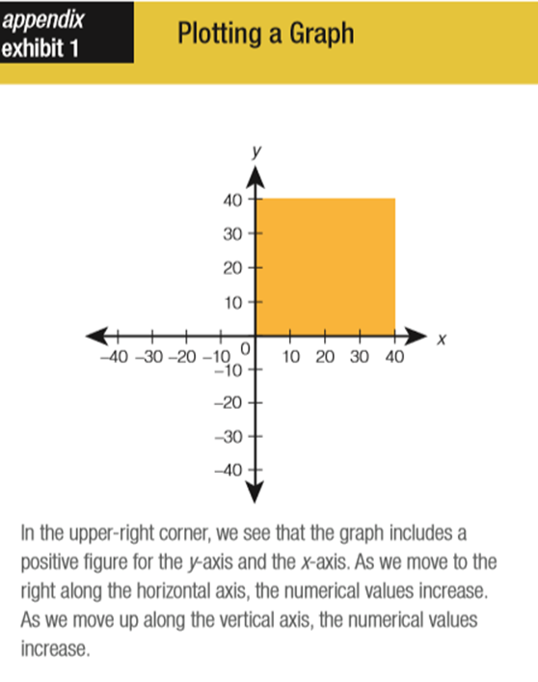
2. Plotting a graph
- In the upper-right corner, we see that the graph includes a positive figure for the y-axis and the x-axis. As we move to the right along the horizontal axis, the numerical values increase. As we move up along the vertical axis, the numerical values increase.
3. Using graphs and charts
- The pie chart shows the revenues received from various taxes levied on households and corporations. Each slice in the pie chart represents the percentage of finances that are derived from one of several different sources.
- The bar graph shows the unemployment rate by age and sex in the U.S. The height of the line represents the unemployment rate. Bar graphs are used to show a comparison of quantities.
- The time-series graph shows changes in the value of a variable over time. This visual tool allows us to observe important trends over a certain time period. This graph shows trends in the inflation rate over time. The horizontal axis shows us the passage of time, and the vertical axis shows us the inflation rate (annual percent change). From the graph, we can see the trends in the inflation rate from 1960 onwards.
4. Using graphs to show the relationship between two variables
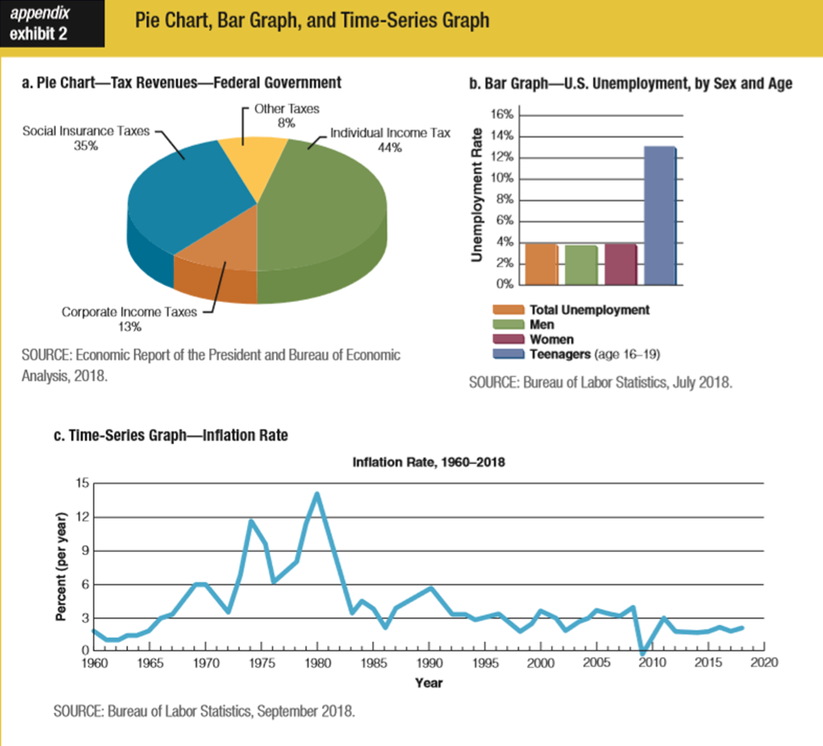
- A variable is something that is measured by a number, such as your height.
- A positive relationship means that the variables change in the same direction. That is, an increase in one variable (practice time) is accompanied by an increase in the other variable (overall score), or a decrease in one variable (practice time) is accompanied by a decrease in the other variable (overall score).
- When two variables change in opposite directions, they have an inverse relationship, also called a negative relationship. That is, when one variable rises, the other variable falls, or when one variable decreases, the other variable increases.
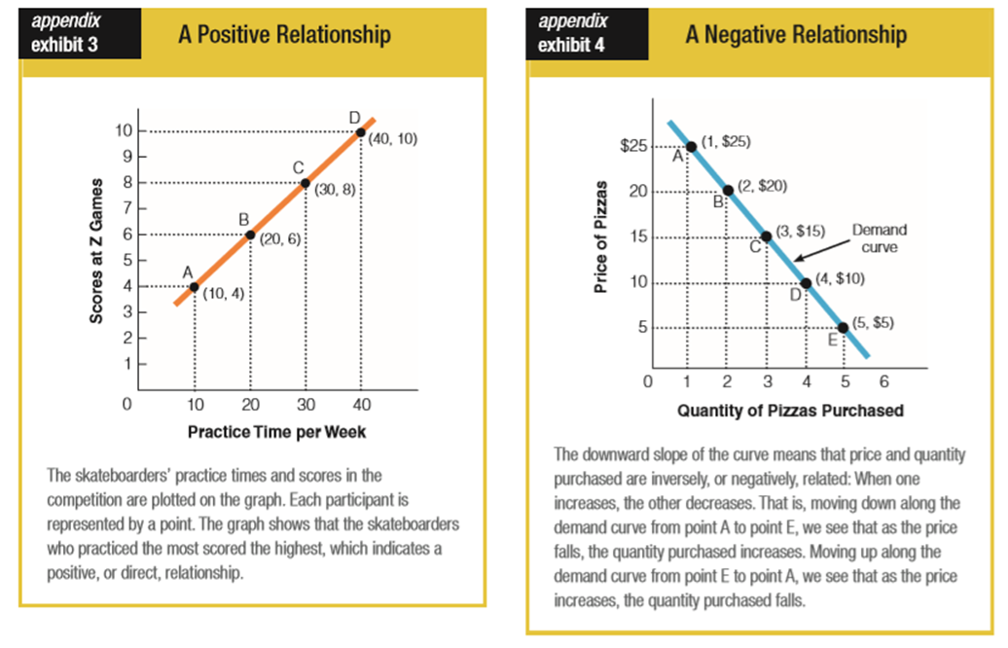
5. The graph of a demand curve
- Let’s now examine one of the most important graphs in economics—the demand curve.
- In the graph in Exhibit 4, we see Emily’s individual demand curve for pizzas per month.
  - It shows the price of pizzas on the vertical axis and the quantity of pizzas purchased per month on the horizontal axis.
  - Every point in the space shown represents a price and quantity combination.
  - The downward-sloping line, labeled “Demand curve,” shows the different combinations of price and quantity purchased.
  - Note that the higher the price of the pizzas (as shown on the vertical axis), the smaller the quantity purchased (as shown on the horizontal axis), and the lower the price (shown on the vertical axis), the greater the quantity purchased (shown on the horizontal axis).
6. Using graphs to show the relationship among three variables
- Although only two variables are shown on the axes, graphs can be used to show the relationship among three variables.
- For example, say we add a third variable—income—to our previous example. Our three variables are now income, price, and quantity purchased.
  - If Emily’s income rises—say that she gets a raise at work—she is now able and willing to buy more pizzas than before at each possible price. As a result, the whole demand curve shifts outward (to the right) compared with the old curve. That is, the new income gives her more money to use to buy more pizzas.
  - On the other hand, if her income falls—say that she quits her job to go back to school—she will have less income to buy pizzas. A decrease in this variable causes the whole demand curve to shift inward (to the left) compared with the old curve.
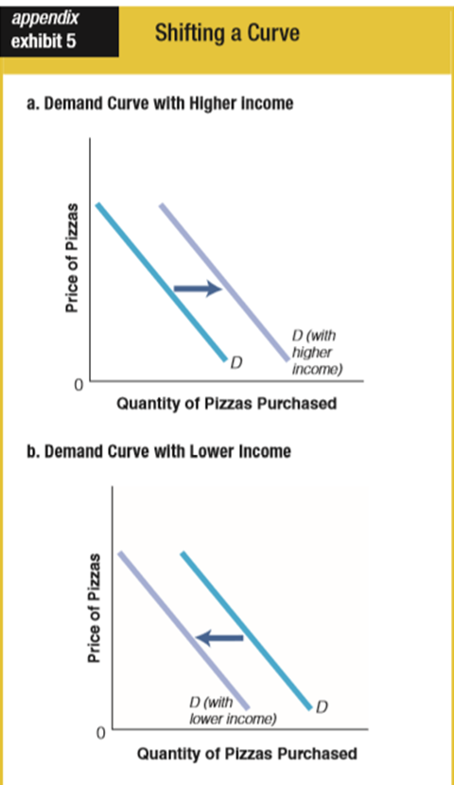

7. The difference between a movement along and a shift in the curve
- It is important to recognize the difference between a movement between one point and another along a curve and a shift in the whole curve.
  - A change in one of the variables on the graph, such as price or quantity purchased, will cause a movement along the curve, say from point A to point B.
  - A change in one of the variables not shown (held constant in order to show only the relationship between price and quantity), such as income in our example, will cause the whole curve to shift.
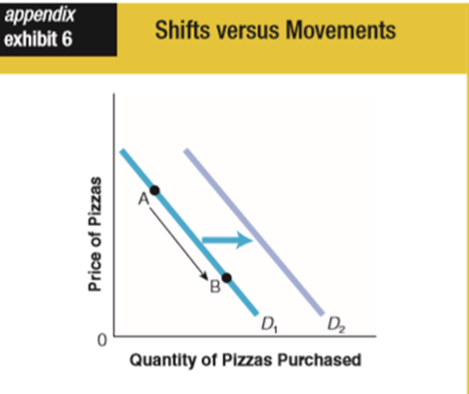

8. Slope
- In economics, we sometimes refer to the steepness of a line or curve on a graph as the slope.
- A slope can be either positive (upward sloping) or negative (downward sloping). A curve that is downward sloping represents an inverse, or negative, relationship between the two variables and slants downward from left to right. A curve that is upward sloping represents a direct, or positive, relationship between the two variables and slants upward from left to right.
- The numeric value of the slope shows the number of units of change of the y-axis variable for each unit of change in the x-axis variable. Slope provides the direction (positive or negative) as well as the magnitude of the relationship between the two variables.

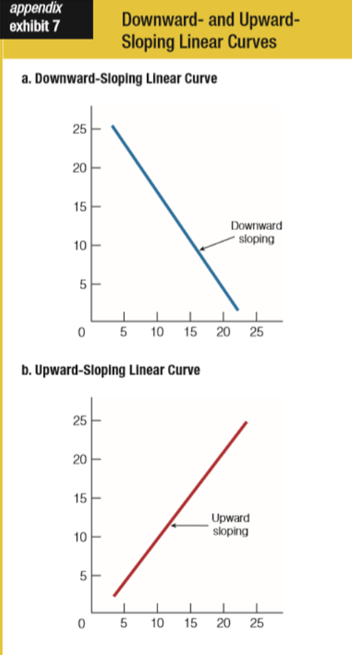

- Measuring the slope of a linear curve
  - A straight-line curve is called a linear curve.
  - The slope of a linear curve between two points measures the relative rates of change of two variables.
  - Specifically, the slope of a linear curve can be defined as the ratio of the change in the Y value to the change in the X value.
  - The slope can also be expressed as the ratio of the rise over the run, where the rise is the vertical change and the run is the horizontal change.

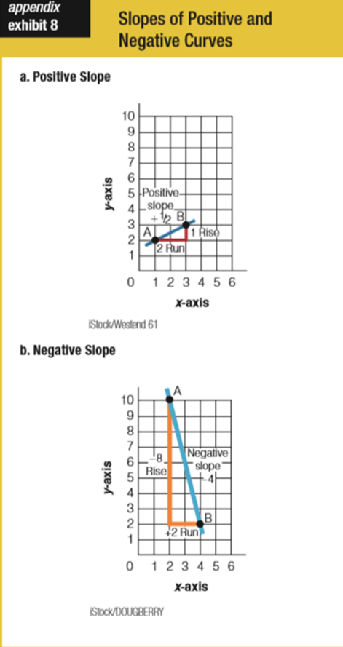
- Finding the slope of a nonlinear curve
  - A nonlinear curve is a line that actually curves.
  - Here the slope varies from point to point along the curve. However, we can find the slope of this curve at any given point by drawing a straight-line tangent to that point on the curve.
  - A tangency is a point where a straight line just touches the curve without actually crossing it. At point A, we see that the positively sloped line that is tangent to the curve has a slope of 1: the line rises 1 and runs 1. At point B, the line is horizontal, so it has zero slope. At point C, we see a slope of –2 because the negatively sloped line has a rise of –2 (a fall of 2) for every run of 1.

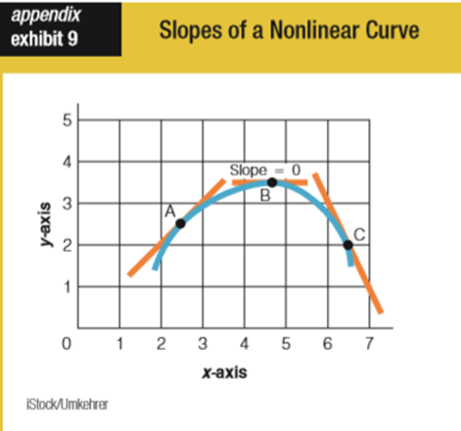

Key Terms and Concepts
Bar graph: a visual display showing the comparison of quantities
Negative relationship: when two variables change in opposite directions
Pie chart: a visual display showing the relative size of various quantities that add up to 100 percent
Positive relationship: when two variables change in the same direction
Slope: the ratio of rise (change in the y variable) over run (change in the x variable)
Time-series graph: a visual tool to show changes in a variable’s value over time
Variable: something that is measured by a number, such as your height
X-axis: the horizontal axis on a graph
Y-axis: the vertical axis on a graph

Problems
1. The following table gives the prices and quantity demanded of oranges (in pounds) for the week of December 10–16.
Price ($/lb) | Quantity demanded (lb)
$0.80 | 0
0.70 | 3
0.60 | 4
0.50 | 5
0.40 | 7
a. Plot the data from the table into a graph.
b. Is it a positive or negative relationship? Explain.
Ans: We have created a negatively sloped demand curve. That is, the price and quantity demanded of oranges are inversely related:
↑P ⇒ ↓Q_{D} and ↓P ⇒ ↑Q_{D}
The demand curve records the pounds of oranges a consumer desires at various prices in a given week, holding all other factors fixed. Because the individual desires more oranges at lower prices, the demand curve slopes downward.
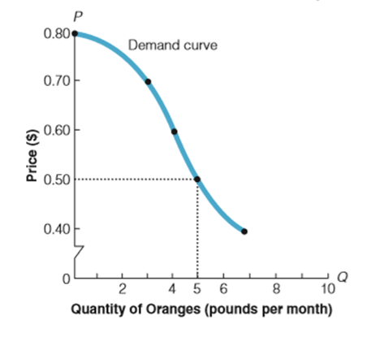
2. Which of the following will lead to a positive relationship? A negative relationship?
a. hours studied and grade in a course
b. the price of ice cream and the amount of ice cream purchased
c. the amount of seasonal snowfall and the sale of snow shovels
Ans:
a. positive
b. negative
c. positive

3. Below is Emily’s demand curve for pizza. How do we add income, a third variable, to price and quantity purchased on our graph? Using a graph, explain what would happen if Emily had an increase in income. What would happen if Emily had a decrease in income?
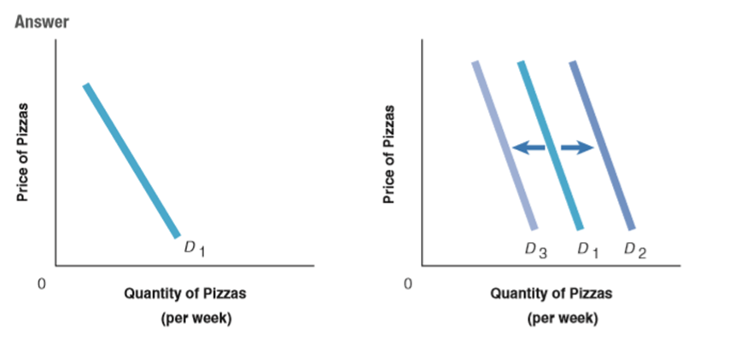

Ans: When income increases, Emily can purchase more pizzas at each and every price—a rightward shift from D₁ to D₂. If Emily’s income falls, her demand will shift leftward from D₁ to D₃.

4. Use the information in the following table to plot a graph. Is it a positive or negative relationship? What is the slope?
x | y
1 | 2
2 | 4
3 | 6
4 | 8
5 | 10

Ans:
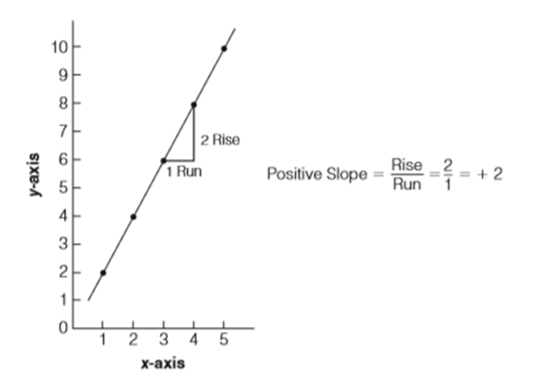

5. What is a pie chart? Bar graph? Time-series graph?
Ans: Pie charts are used to show the relative size of various quantities that add up to 100 percent. Bar graphs are used to show a comparison of quantities of similar items. Time-series graphs allow us to see important trends over a period of time.

